LAB EXPERIMENT RECORD
SET 20: Stock Analysis
Department | AI&DS
Course Code / Course Name | DSA0602 / Data Handling and Visualization
Experiment | Data Visualization using R
Name | Peram Mahitha
Register Number | 192524136
Date | 12 OCTOBER 2026
Day | Tuesday

SET 20: Stock Analysis
Aim:
To visualize stock price trends for three companies over a specific period using line charts, bar charts, and summary tables in R, along with an interactive Tableau dashboard.
Dataset: Stock Prices
Date | Stock A | Stock B | Stock C
2023-01-01 | 100 | 150 | 120
2023-01-02 | 105 | 152 | 118
2023-01-03 | 110 | 148 | 122
PROGRAM 1: Line Chart (Stock Price Trends)
Aim: To visualize stock price trends for three companies over time.
R Program:

graphics.off()

date <- as.Date(c("2023-01-01",
"2023-01-02",
"2023-01-03"))

stock_a <- c(100, 105, 110)
stock_b <- c(150, 152, 148)
stock_c <- c(120, 118, 122)

plot(date, stock_a,
type = "b",
col = "blue",
ylim = c(90, 160),
xlab = "Date",
ylab = "Stock Price",
main = "Stock Price Trends")

lines(date, stock_b, type = "b", col = "red")
lines(date, stock_c, type = "b", col = "darkgreen")

legend("topleft",
legend = c("Stock A", "Stock B", "Stock C"),
col = c("blue", "red", "darkgreen"),
lty = 1,
pch = 1)
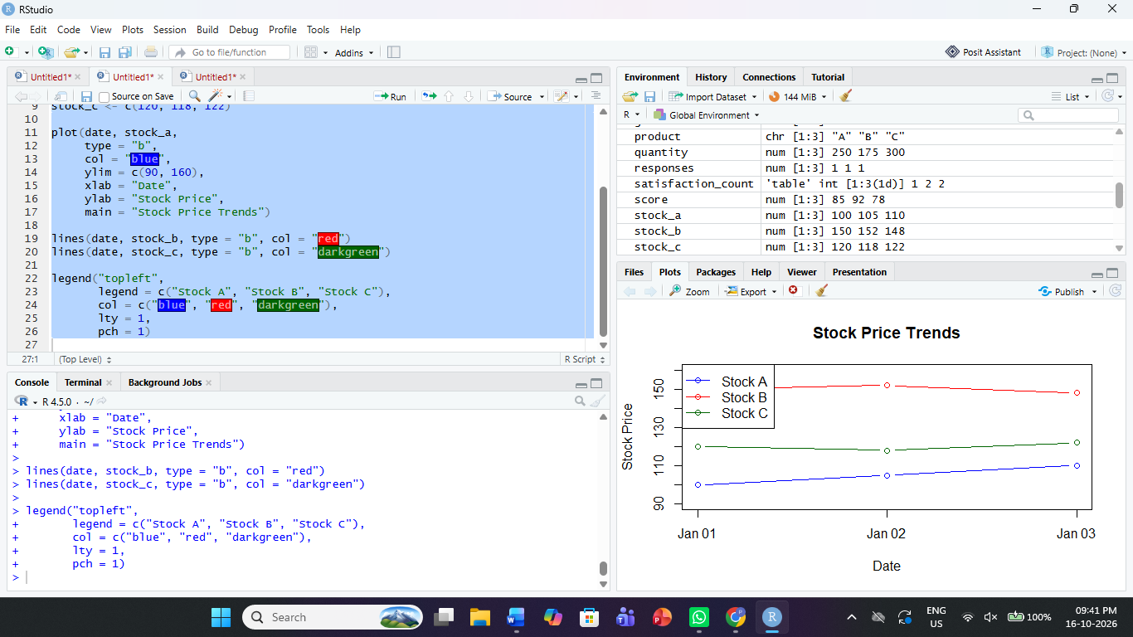
Observation: Stock A increases from 100 to 110, Stock B increases slightly before falling to 148, and Stock C falls before rising to 122.
PROGRAM 2: Bar Chart (Stock A Price Changes)
Aim: To display the daily stock prices of Stock A using a bar chart.
R Program:

graphics.off()

date <- c("Jan 1", "Jan 2", "Jan 3")
stock_a <- c(100, 105, 110)

barplot(stock_a,
names.arg = date,
col = "skyblue",
main = "Stock A Price Changes",
xlab = "Date",
ylab = "Stock Price")

text(x = c(0.7, 1.9, 3.1),
y = stock_a,
labels = stock_a,
pos = 3)
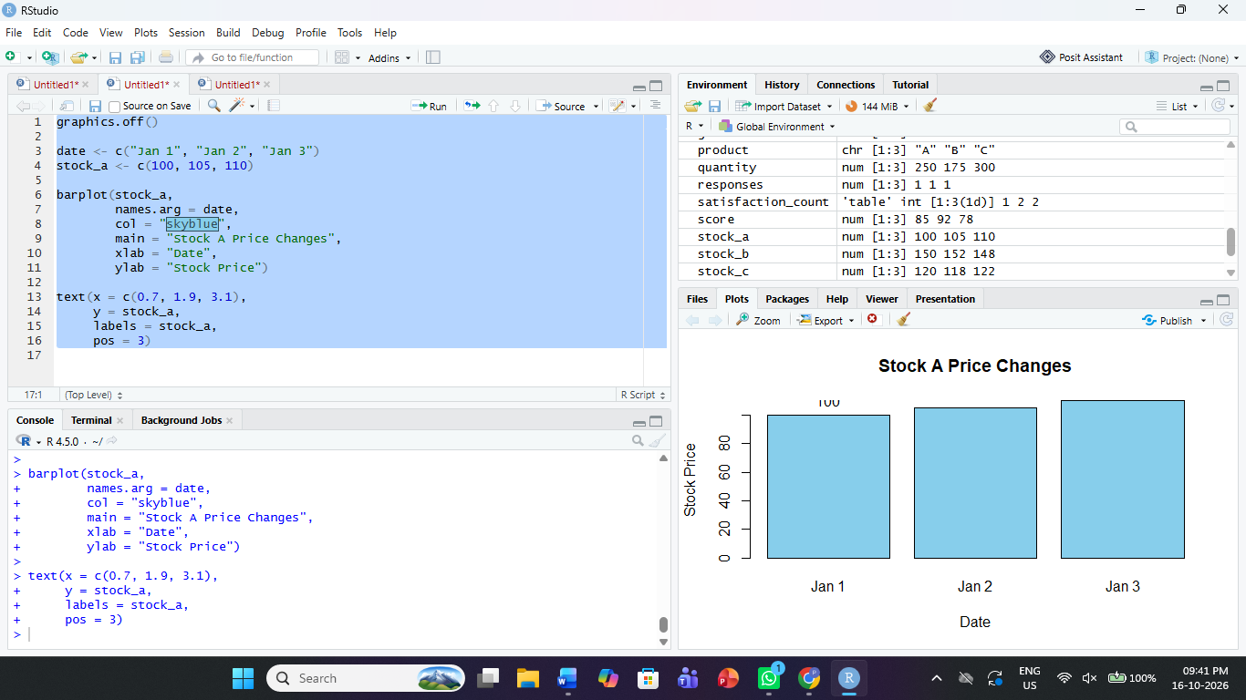
Observation: The bar chart shows that Stock A's price rises from 100 to 110 over the three dates.
PROGRAM 3: Stock Price Summary Table
Aim: To create a structured table showing stock prices for all three companies.
R Program:

stock_data <- data.frame(
Date = c("2023-01-01",
"2023-01-02",
"2023-01-03"),
StockA = c(100, 105, 110),
StockB = c(150, 152, 148),
StockC = c(120, 118, 122)
)

print("--- Stock Price Summary ---")
print(stock_data)
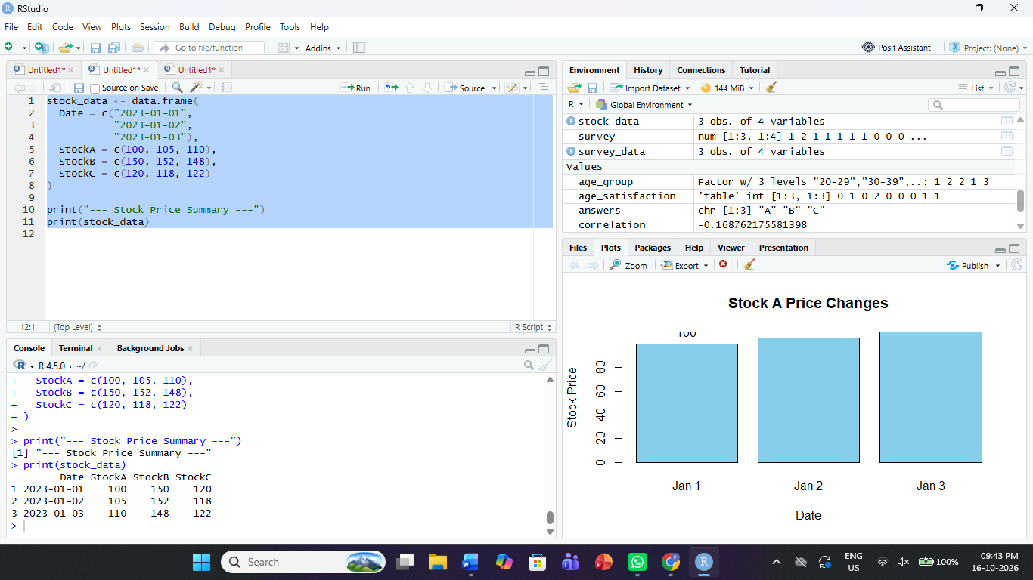
Observation: The table displays daily prices for all three stocks. Stock A shows a continuous increase during the given period.
PROGRAM 4: Stock Analysis Dashboard in Tableau
Aim: To create an interactive dashboard combining stock price trends, a stock price bar chart, and a summary table.
Steps in Tableau:
- Save the dataset as Stock_Prices.csv and connect it to Tableau.
- Sheet 1 – Stock Price Line Chart: Use Date on Columns and stock prices on Rows. Pivot the three stock columns if needed to display all three stocks using color.
- Sheet 2 – Stock A Bar Chart: Use Date and Stock A to create a bar chart.
- Sheet 3 – Stock Price Table: Display Date, Stock A, Stock B, and Stock C.
- Create a dashboard and arrange all three sheets.
- Enable Use as Filter for interactive exploration.
Observation: The dashboard combines stock price trends, individual stock comparisons, and daily records. Users can filter dates and stocks to examine price movements.
Procedure:
- Create vectors for dates and stock prices.
- Use plot() and lines() to display the stock price trends.
- Use barplot() to compare Stock A prices.
- Create a data frame containing all stock prices.
- Combine the visualizations in a Tableau dashboard.
Result:
Stock price data was visualized using line charts, a bar chart, and a summary table in R. An interactive stock analysis dashboard was designed in Tableau.

